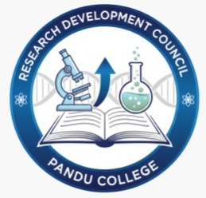

THE JOURNEY OF RESEARCH DEVELOPMENT AT PANDU COLLEGE
Pandu College has long been recognized as an institution committed to academic excellence, and this commitment took a significant step forward in 2017 with the establishment of its Research Cell. The primary objective of this cell was to nurture a culture of inquiry and innovation among students and faculty. From its inception, the Research Cell began organizing a wide range of programs designed to promote research activities. Most of these initiatives focused on applied research across diverse disciplines, with the aim of enhancing students’ academic performance and equipping them with practical skills that extend beyond the classroom.
Over the years, the Research Cell became a hub of intellectual engagement, encouraging students to explore new ideas and methodologies. Recognizing the evolving educational landscape and the emphasis placed on research in the National Education Policy (NEP), the institution decided to rebrand and expand the scope of the cell. Thus, the Research Cell was renamed the Research Development Council (RDC), reflecting its broader mission of fostering skill enhancement programs through a multidisciplinary approach.
From the inception of the council completed many research oriented program for both faculty and student community. One of the landmark initiatives undertaken by the RDC was the research-oriented internship program conducted in 2025. This program attracted a large number of students, who actively participated in hands-on research experiences. The internship was organized in collaboration with several Central Government and Government of Assam organizations under the My Bharat Abhiyan. Key partners included the National Disaster Response Force (NDRF), Assam Skill Development Mission (ASDM), and the National Service Scheme (NSS). These collaborations provided students with exposure to real-world challenges and opportunities to apply their knowledge in practical contexts, thereby bridging the gap between academic learning and societal needs.
In addition to internships, the RDC launched a Minor Research Project Sponsored Program exclusively for Pandu College Teacher and students. This initiative was designed to cultivate academic and research excellence under a multidisciplinary framework. Beginning in February 2018, where 5nos. of projects (Rs. 50 thousand for each) had sponsored and the faculty members were actively engaged in the work. Thereafter, in 2025, the Council initiates multidisciplinary framework for the research and the program supported five student-led projects, each funded with an amount of Rs. 20,000 for each. Remarkably, all five projects were successfully completed within the stipulated time frame, showcasing the dedication and capability of the students involved. These projects not only enriched the participants’ academic journey but also contributed to the broader research culture of the institution.
The success of the Minor Research Project program has inspired the RDC to continue its efforts. Subsequently, the Council announced the next round of project opportunities, inviting students to engage in innovative research. By providing financial support, mentorship, and a structured framework, the RDC ensures that students can pursue their ideas with confidence and rigor. This initiative underscores the college’s commitment to nurturing future researchers who can contribute meaningfully to society.
The Research Development Council at Pandu College represents a visionary step toward integrating research with education. Through internships, collaborative programs, and sponsored projects, the RDC has created a vibrant ecosystem that empowers students to excel academically while developing critical research skills. As the Council continues to expand its initiatives, it reaffirms Pandu College’s dedication to fostering innovation, multidisciplinary learning, and academic excellence for generations to come.
Coordinator/Nodal Officer Chairperson President
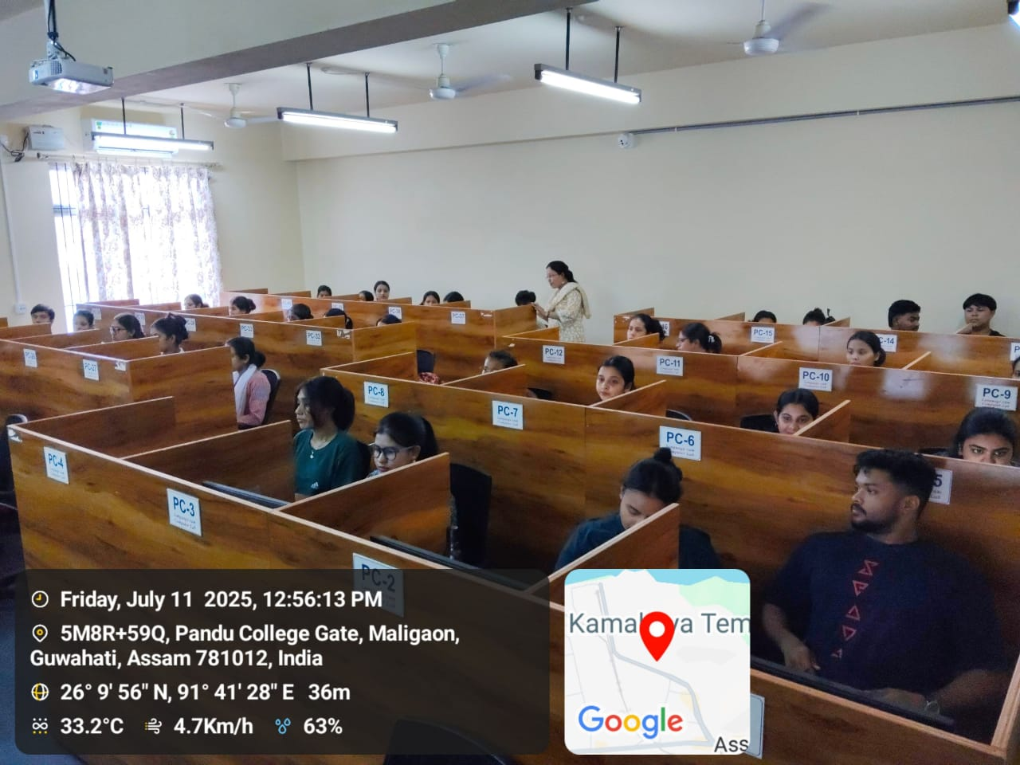
A Computer Training Session under RDC, 11th July, 2025

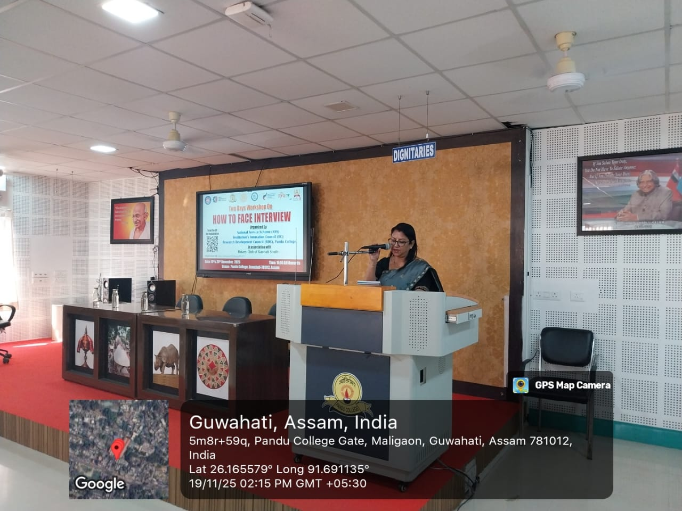
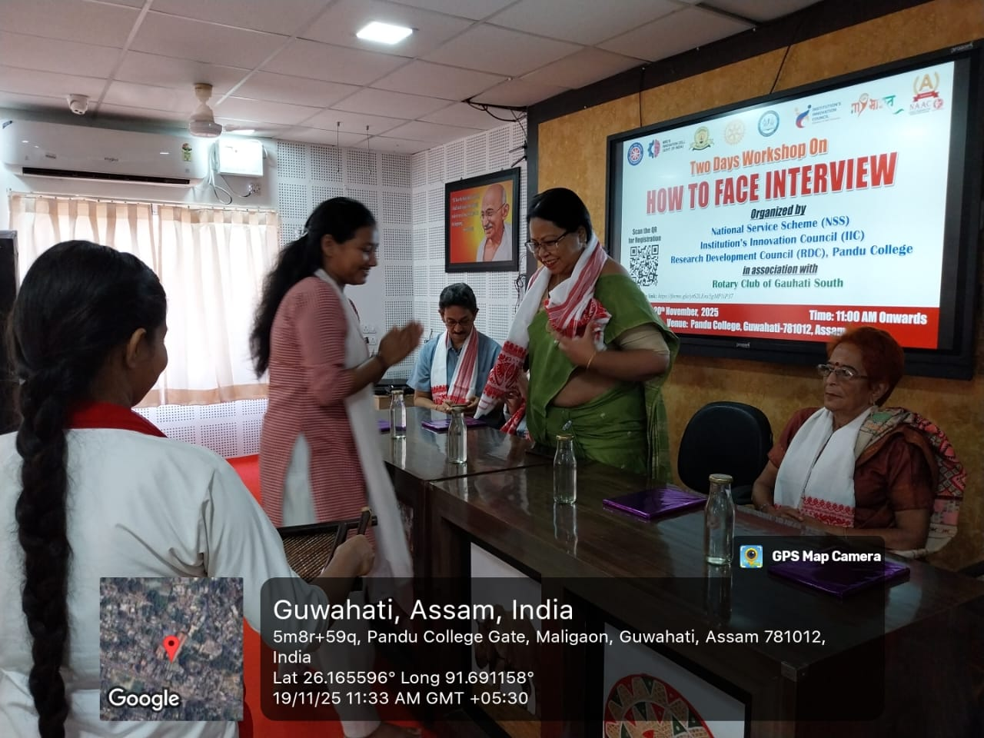
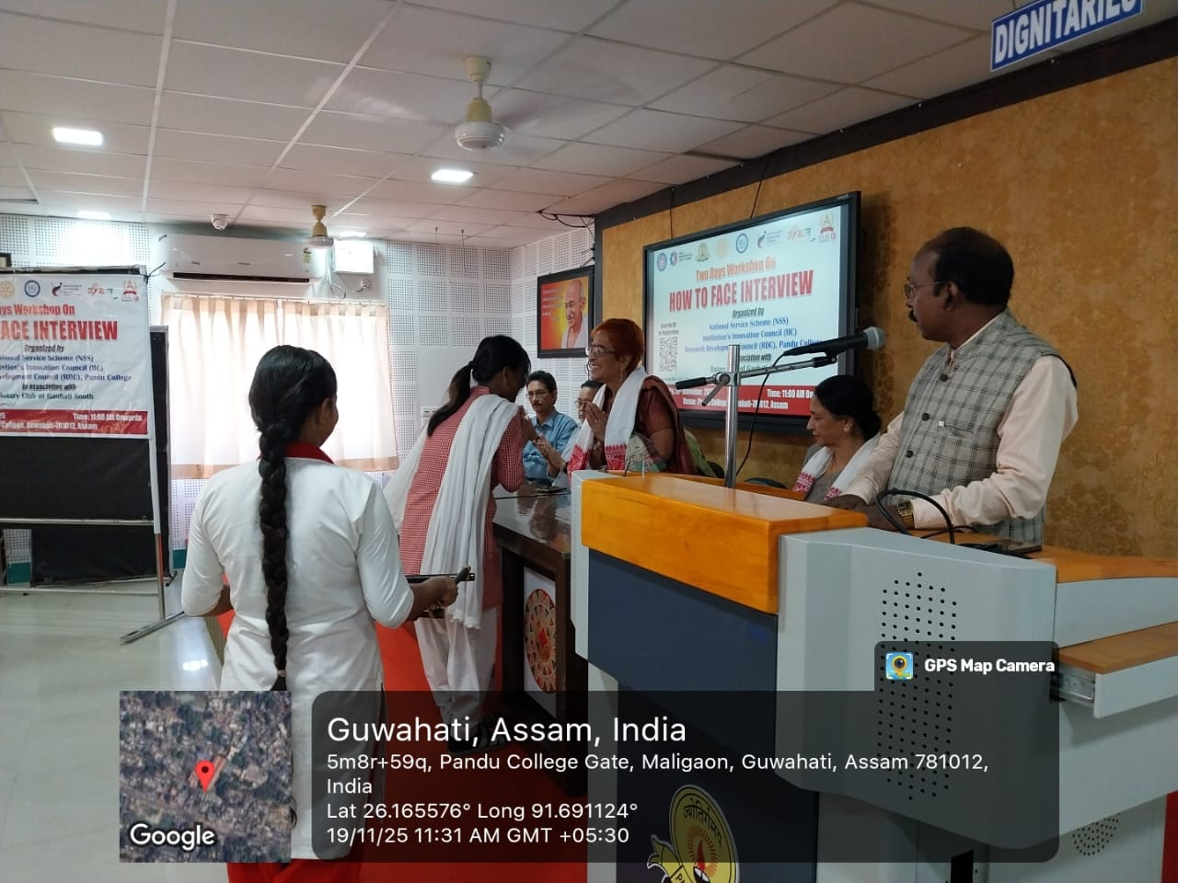
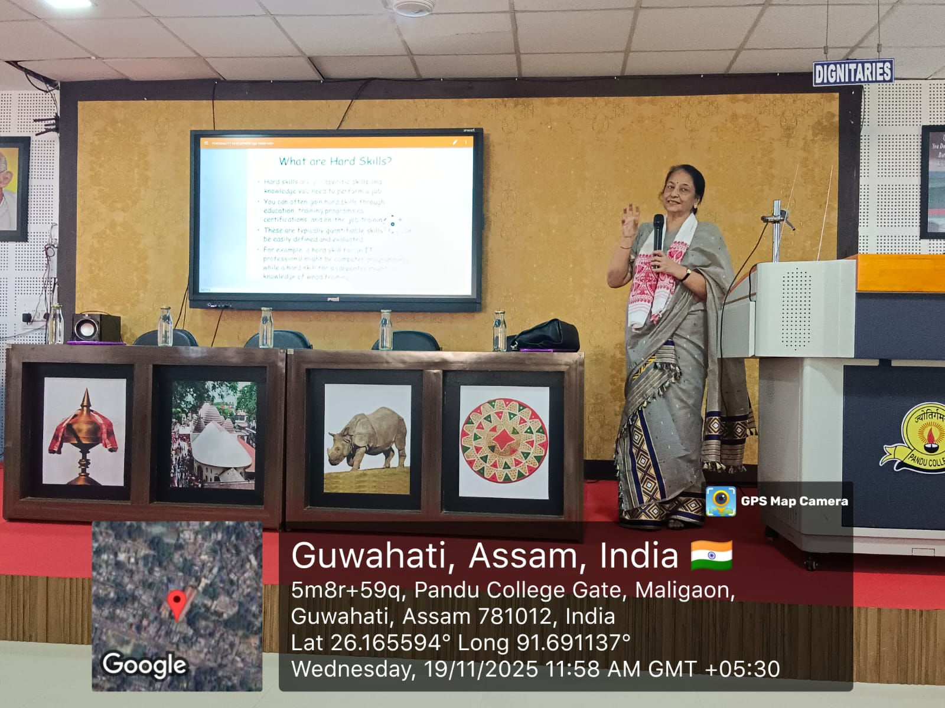
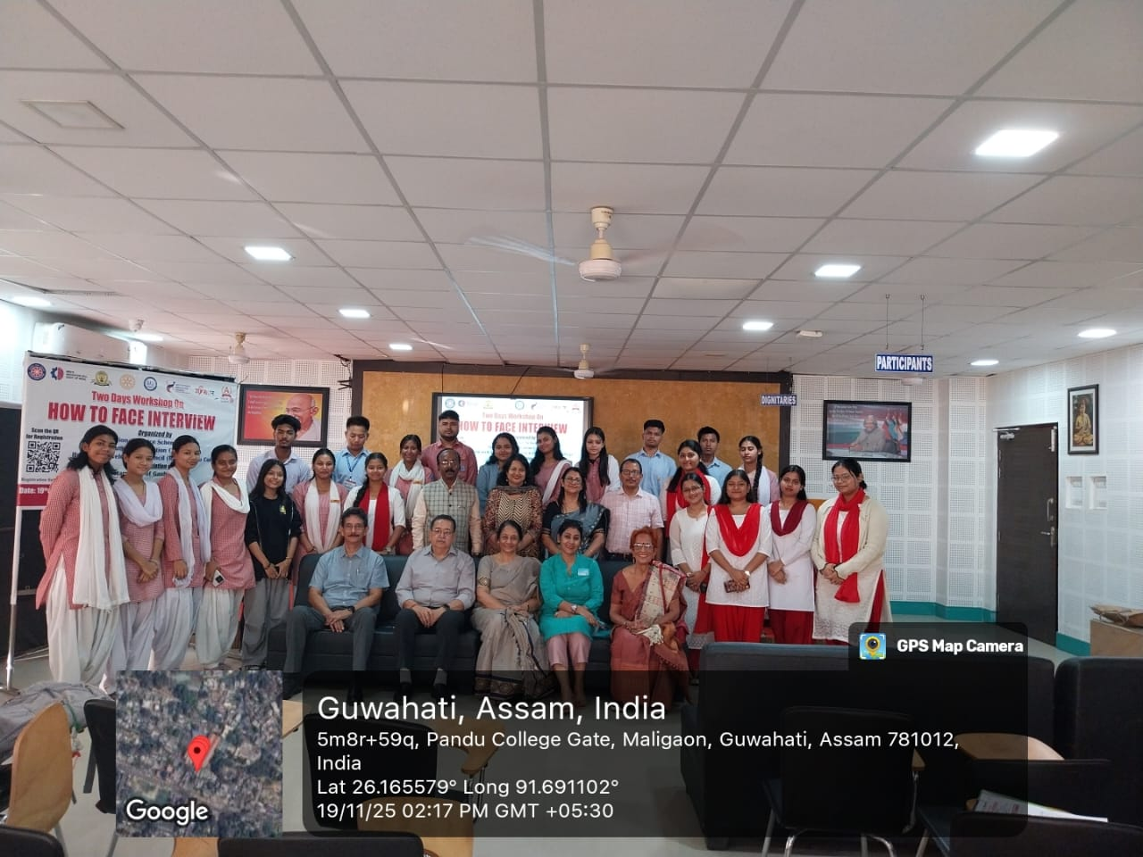
An Interactive Program under RDC, 19th November, 2025

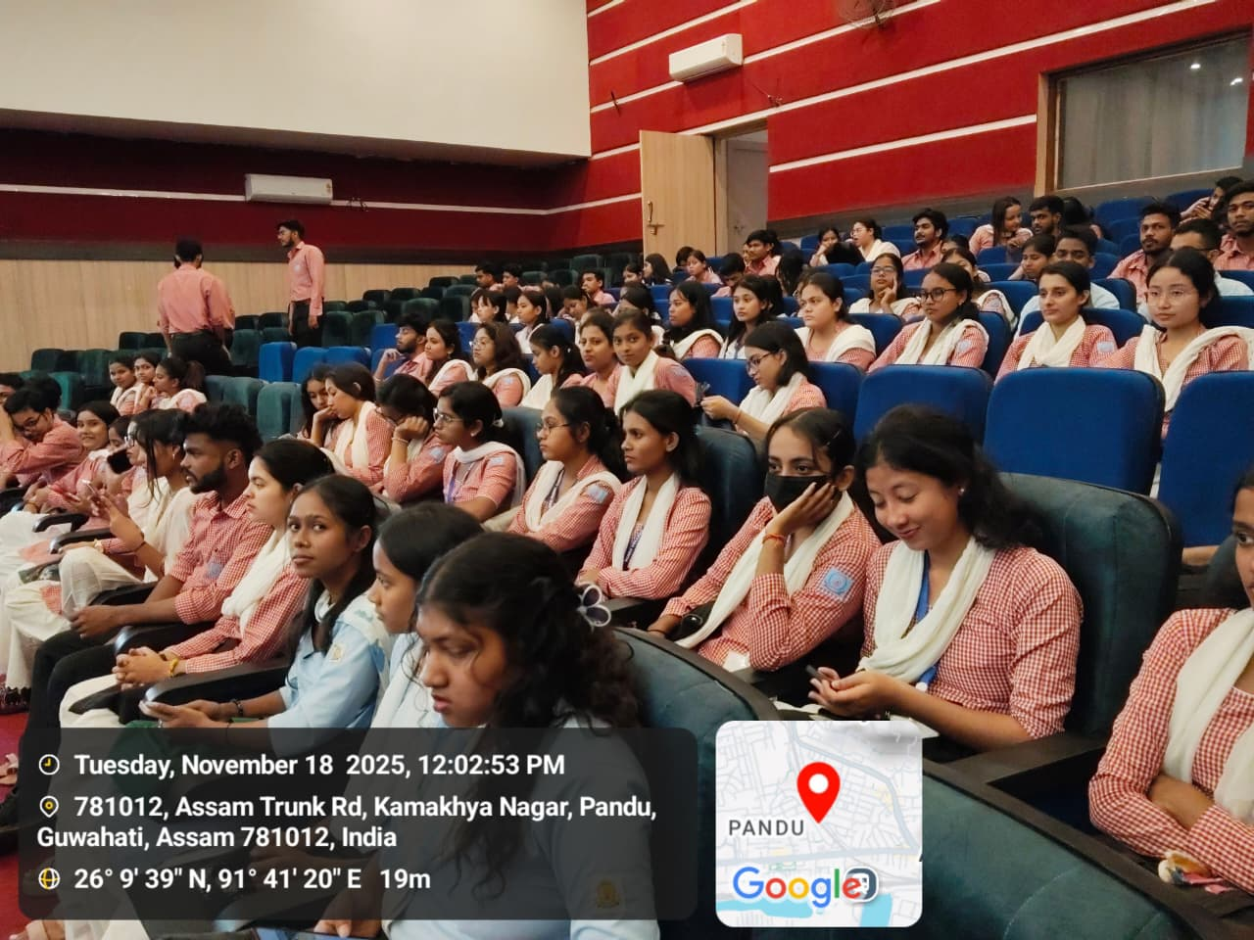
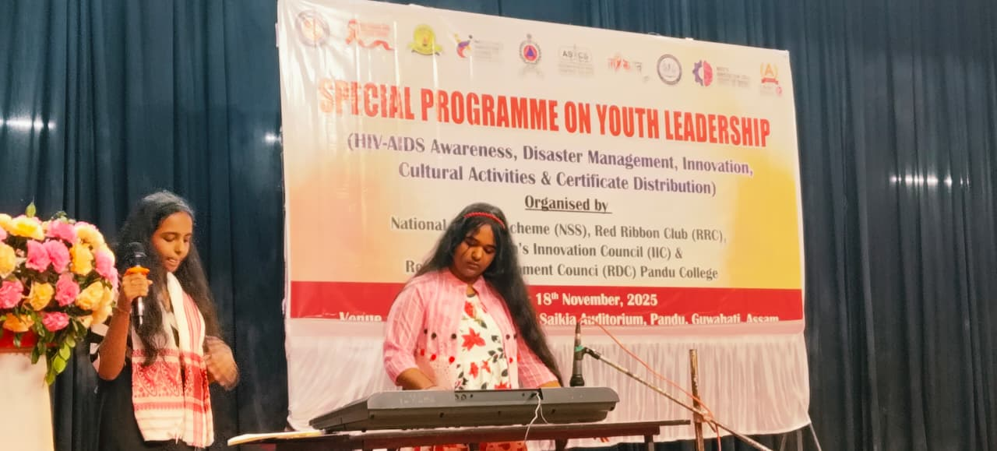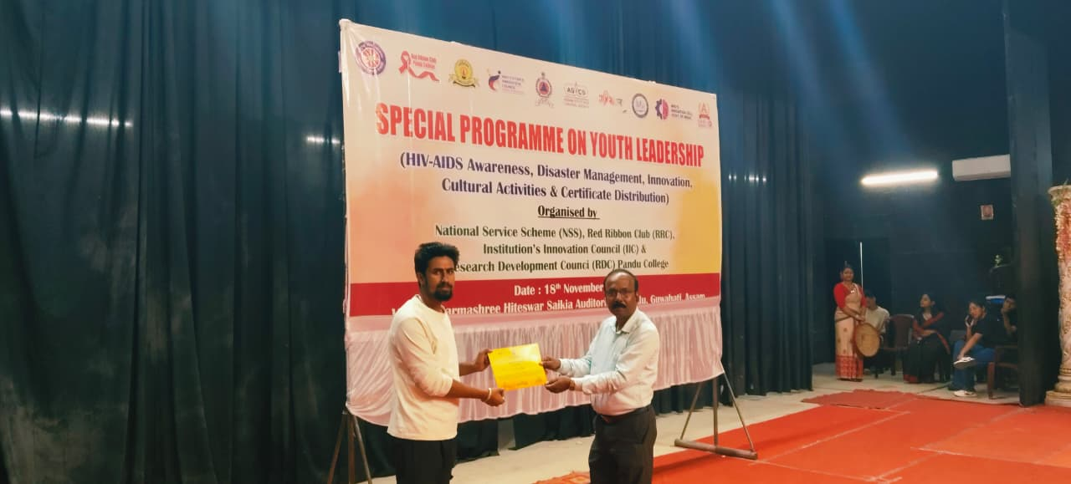
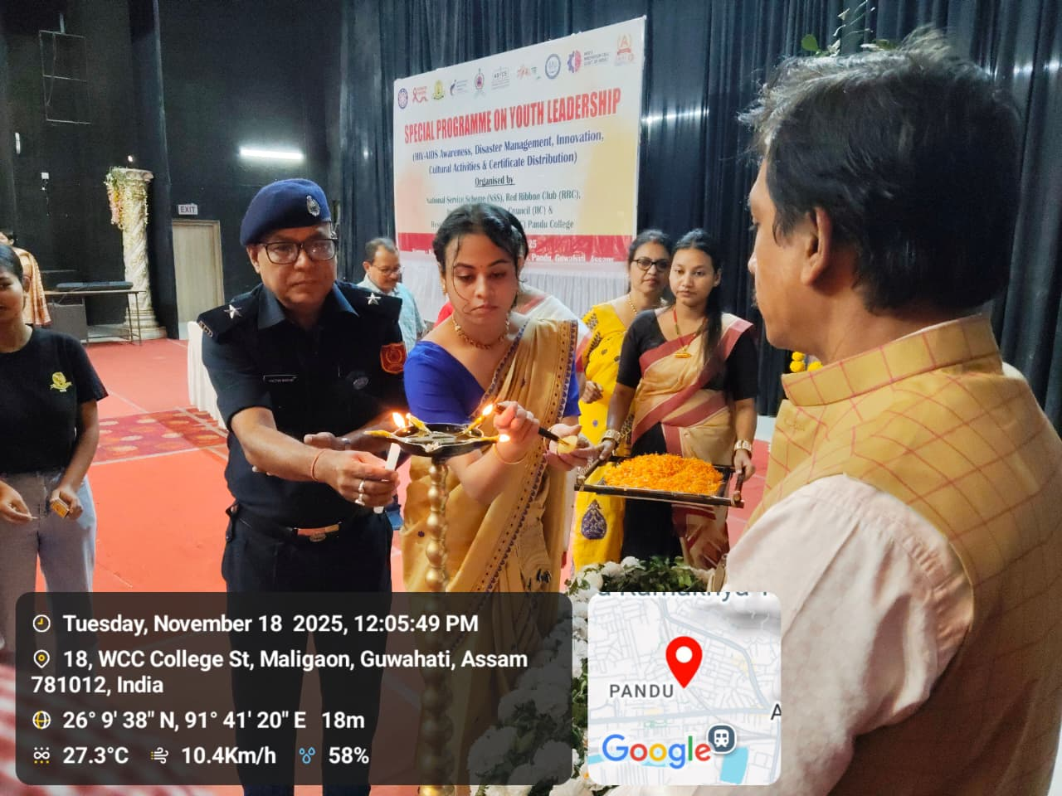
Leadership Building Program under RDC, 18th November, 2025

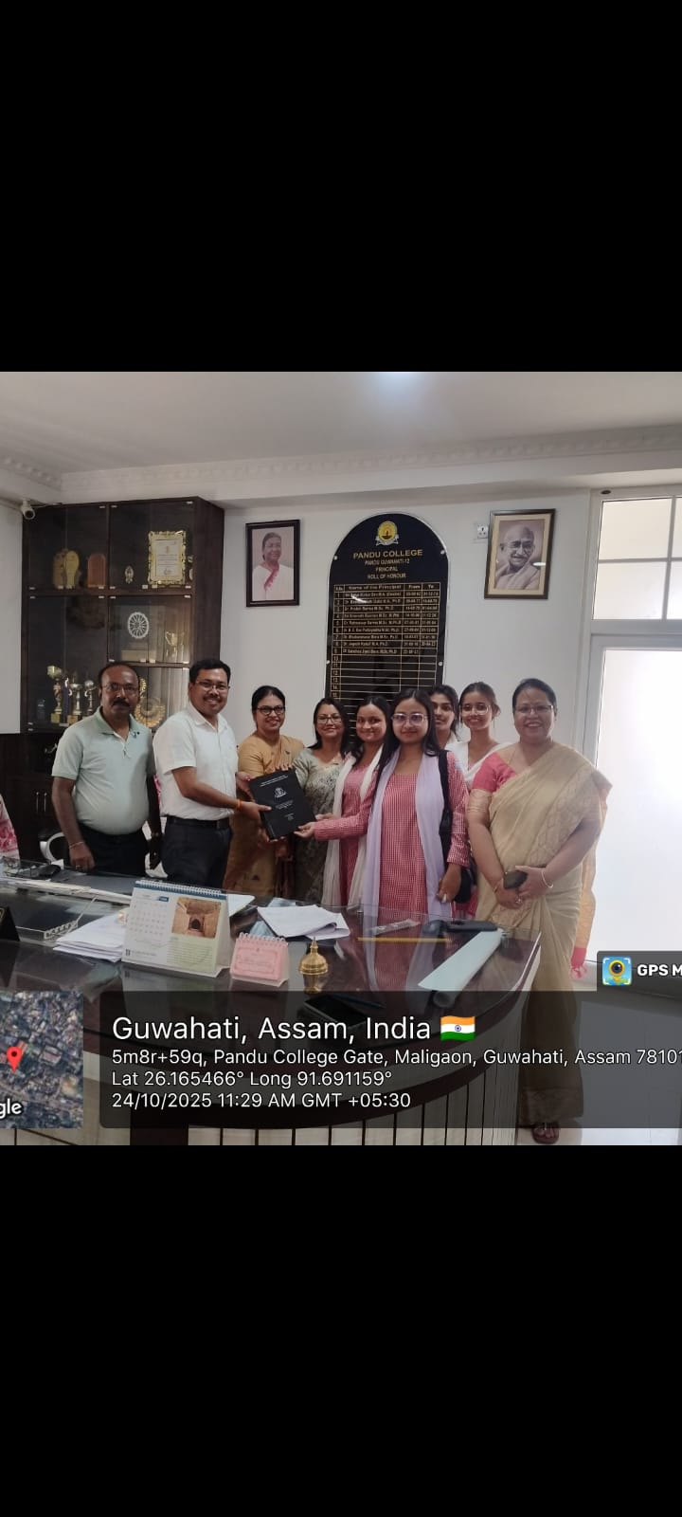
At the time of Submission of Final MRP Report under RDC, 2025

